UI 23-16: Creating a Chop Color Database
Primary Researcher:
Objective: The goal of this project is to develop a database of chop images and their matching loin quality data to use for consumer perception studies.
Tasks:
- Rename chop image files based on a consistent naming convention
- Develop master data files with the consistent study info, chop image file name, and loin quality traits.
Renaming Protocol (Task 1):
- For each individual project (I.e. UI 20-03, UI 20-04, UI 20-10, etc…), create a project folder within the UI 23-16 Chop Color Database. (I.e. Within UI 23-16, create a folder labeled in the same way as it was originally.)
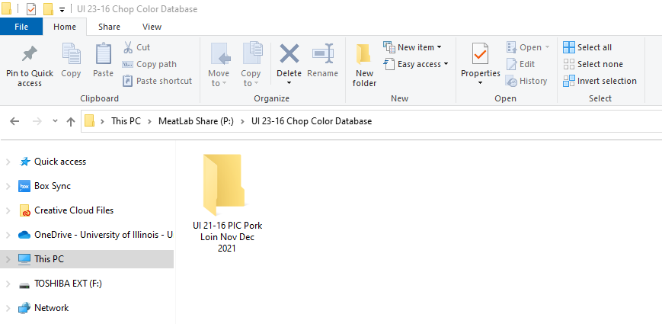

- COPY image files from respective projects into their corresponding folder within UI 23-16. (NOTE: Do NOT remove image files from their original project folder, instead copy these files into their new home in UI 23-16.)
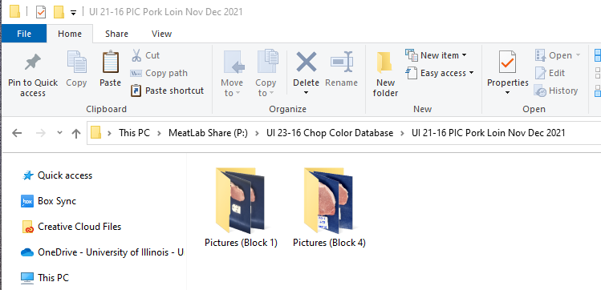

- Rename files using the following naming convention:
_ _ _ _B_ _ C_ _ _ _D_ _
Study number
Chop Number
Block
Day of display

- Study number – This is the four digit number on the project folder (I.e. For picture above, the study number would be 2116.) DO NOT include dashes in study number.

- Block – This will be a two-digit number. If project includes a block (obvious above, but may look differently depending on the original project folder) include this here. (I.e. For the picture above, the block would be 01 and 04.) If the study does not have a block, enter “00” (No block)

- Chop number – This will be a four-digit number. The chop ID number is included on the tag in pictures. Not all chops will have four digits. Enter “0” in any spaces where there is not a number (I.e. If chop number on tag is 1, enter “0001”. If chop number is 134, enter “0134”.)

- Day of display – This will be whatever day of retail display the photos represent. This will not likely be included on the tag in photos. Instead, in cases where the chops were part of a retail display study, the photos will usually be in a subfolder labeled by day. If chop pictures were taken during loin quality and NOT included in a retail display study, enter “00” (No shelf life).

Example: Chop ID – 1514B02C0123D05
Study: 15-14
Block: Block 2
Chop: ID 123
Day: Day 5 of display

Example:
Study: 14-14
Block: Block 3
Chop: ID 3-110
Day: No retail display
Chop ID – 1414B03C3110D00

Develop Consistent Master Data files (Task 2):
- For each individual project (I.e. UI 20-03, UI 20-04, UI 20-10, etc…), COPY master loin quality files from respective projects into their corresponding folder within UI 23-16. (NOTE: Do NOT remove files from their original project folder, instead copy these files into their new home in UI 23-16.)

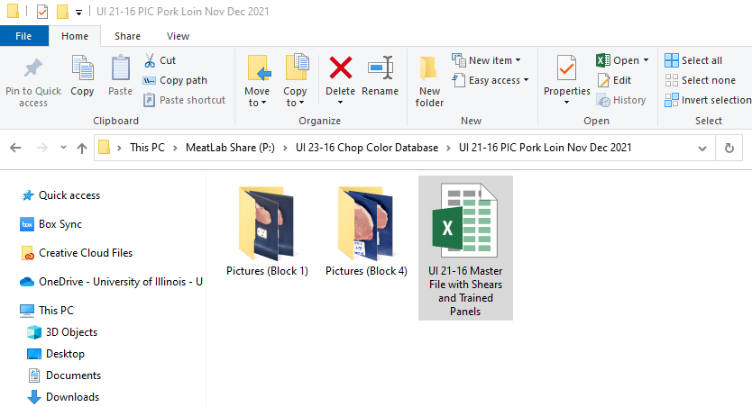

- Open the Master data file template in the UI 23-16 Color Database folder AND the master loin quality file from respective projects. (I.e. For the picture above, UI 21-16 Master File with Shears and Trained Panels)

- Copy data from columns in original master data file to new template. Column headers will look different from study to study. If you have questions about whether the column you are looking at matches the template column, ask a grad student, Dr. Harsh, or Dr. Dilger. Some columns will NOT be present in every original master file. Some of these will be added to the template column anyway (I.e. Study number won’t be in a data column but can be easily added using the study number of the original master file). Some of the data simply does not exist for some projects (I.e. Maybe we don’t have sex or sireline information). In these cases, we will enter a period “.” in all cells where there is missing data.

- When complete or stopping, SAVE AS the resulting template with data filled-in. Change the File name to: “UI __-__ Standardized Master Data File”. Save file to the project folder within the UI 23-16 Chop Color Database project.

